Grid Data Resources Integration and Problem Knowledge Exchange
within Information Society Structures

Zbigniew Kierzkowski

Networked Virtual Activities Organization Laboratories: Lodz–Olsztyn–Polkowice–Poznan,
The College of Computer Science, Rzgowska 17a, 93–008 Lodz, Poland,
e-mail: zbigniew.kierzkowski@neostrada.pl; zbigniew.kierzkowski@put.poznan.pl

The interregional research grid infrastructure is built in Poland as an information environment of the VAO–virtual (digital) activities organization systems for modeling of the virtual (digital) organization of the human collaboration and the enterprises co-operation within information society structures.

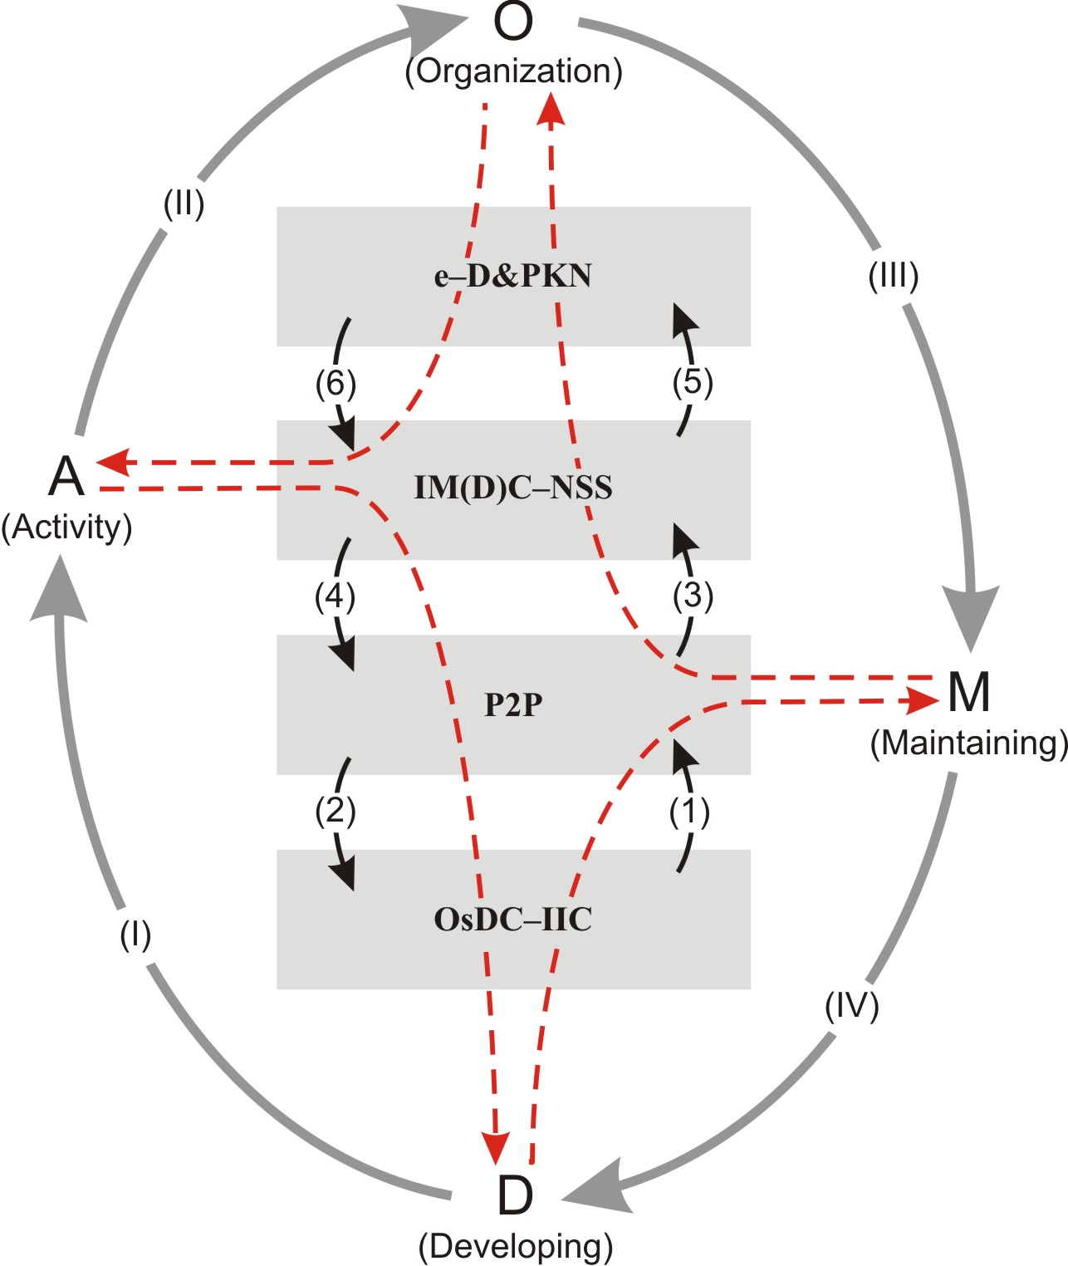

Pictogram of the grid information environment
of the virtual (digital) activities organization
within information society structures

Architecture – Structural organization:
e–D&PKN – The virtual D – digital data and PK – problem knowledge networks. IM(D)C–NSS – Interactive media (direct) communication systems

based on network subject services. P2P – Peer–to–Peer systems: Common information spaces. Random access to integrated virtual digital resources. OsDC–IIC – Open semi–direct communication based on internet information centers: Infrastructure of mutually connected internet information centers.

Architecture – Functional organization:
(1) Random access to the integrated virtual digital content. (2) Files management. (3) Personalization of digital resources for problem knowledge schemas creation. (4) Partnership in exchanging information. (5) Network subject services. (6) Mutual (interactive) exchange of digital resources (contents in cooperative activities).

Functioning – Building and organizing:
Developing (D) of infrastructure is based on modeling and synthesis of software in different VSIS – virtual subject information systems. Organizing (O) includes structuring of D – data resources and PK – problem knowledge.

Functioning – Administration and maintenance:
The problems of activity (A) result from operational features of infrastructure and mean an mutual (interactive) exchange of digital resources. Maintaining (M) – means readiness to the virtual resources (network integrated digital resources).

The models of grid infrastructure VAO systems is composed by four–layer (levels) components. Among the infrastructure architecture layers, two of them are well understood, the first and the fourth. The first layer is a technical component of infrastructure The fourth layer is an organizing component of the infrastructure. The remaining two layers of infrastructure architecture – the second and the third – are speculative (middleware), helpful in describing of the flow of information in the organization of activities in the information society. The second layer is an informative component of infrastructure. The third layer is a communicative component of infrastructure and makes it possible to create communicative structure of VAO systems.

